**Loan Management System**

An Undergraduate Capstone Project Proposal

Presented to the

Panel of Examiners

Cebu Technological University

TABOGON EXTENSION

Poblacion, Tabogon, Cebu

In Partial Fulfillment

Of the Requirements for the Degree

BACHELOR OF SCIENCE IN INFORMATION TECHNOLOGY

Alburo, Jolina S.

Baril, Vicente

Cabahug, Ervin

Quilaton, Francis John

Saladaga, Edrelyn

Subito, Loren

**Chapter I**

**THE PROBLEM AND ITS SCOPE**

**INTRODUCTION**

**Project Context**

Web- based loan management system refers to a computerized application that runs over a network specifically the internet, where one can store, retrieve, delete, update and make other changes to that data which is stored in the database. All this is done over the internet in any location where access is available. Responsibilities under this web-based loan management system include creating a database that can be accessed by the administrators online, adding and removing data, manipulation of data, update and storage.

The Web-based loan security management system as described above was once implemented in other Big financial institutions. Smaller financial institutions like pride microfinance have not yet found such an opportunity to use this kind of a system. Given the numerous benefits that come with computer-based systems, there is need to design such a system for this small institution. Pride Microfinance uses paper-based loan management system, clients fill in forms by pen and the information is stored on paper and sometimes on hard disks and other secondary storage devices. This data is also hard to access unless one is on the premises of Pride Microfinance and also keeping records is hard since it is only stored on hard disks, Compact Disks and other secondary storage systems which get spoilt, crash and sometime stolen. Data is therefore lost and cannot be retrieved. Hence the call for the design of a web-based loan management system.

Web- based loan management system refers to a computerized application that runs over a network specifically the internet, where one can store, retrieve, delete, update and makes other changes to that data which is stored in the database. A web is said to be a powerful medium offering unique marketing, advertising, and product and service information. It eases communication opportunities between an organization and existing potential customers. A web can give access to a greater store of information than other traditional communication media, and provide visitors with the means to select and retrieve. Its unique features such as the website will been described to offer a greater degree of interactivity. The web design, information and interactivity are indispensable components of interaction. The Loan Security Management System uses the web because of its ease of communication, felicitation of access and greater degree of interactivity.

The loan management system that is currently running in some big lending establishments is paper based. This inevitably is not only time wasting but causes substantial poor records keeping. This is evidenced in loss of client information, data redundancy, long queues and as such this raises the need for a web-based loan management system that can facilitate better record keeping and security.

**Purpose and Description of the Project**

The Loan Management System is a Web-based system wherein the primary objective is to help the lending facilitators and lender’s have a secured transaction and decreasing their human efforts in transacting physically at the location.

This system can run online once it is deployed in the internet.

**General Objectives**

The main objective of this project was to design a web-based loan management system that will keep loan data safe and provide security to that data online

**Specific objectives**

* To carry out an investigation on the Loan management system in Pride micro-finance
* To analyze the problems heed by pride microfinance.
* To establish the requirements for the proposed system.
* To design a prototype for a web-based loan management system that will keep loan data safe and provide security to that data.

**Scope and Delimitation**

**Scope**

* To reduce on data redundancy such that clients’ data about loans is not lost.
* To minimize on costs by providing effective and efficient system.
* To generate retrieval of clients’ records concerning the loans taken in Pride microfinance.
* To give authority to the administrators to make changes on the look of the system and also manage data online.
* To ease access of data to the administrator since the system is online and can be accessed anywhere in the world.
* To lead to an award of a Bachelor’s Degree of Deformation Technology at Kampala International University.

**Delimitation**

This proposed Loan Management System does not accept online payment.

**Significance of the Study**

The system will help the loan facilitators decreases their human effort at the same time, data entry will be more secured compared to other method of lending.

**Lending facilitators**

The proposed project will help lending facilitators in doing the transaction details specifically during the calculation of money of the changes after a customer / student have ordered become more secured and effective.

**Lender**

This feature will help the lender to lessen their human effort in going to the location just to apply. With the help of this proposed system, lender’s transactions will be easier and faster and at the same time, calculation for fund changes will be automatically done.

**Chapter 2**

The literature review of this project covers previously researched material from different scholars on loan security and management. Through researchers’ attempts, various theories on how loan management has been; propagated. These theories produce systems to assist managers in loan management, managing information systems in Microfinance institutions, existing information reporting systems, improving management, reporting and the use of data warehousing efficiently to improve management reporting.

**Related Systems**

Online Loan application systems have been developed application of home loan, Car loan, Education loan, gold loan, Business loan and online Customer acquisition solution an online platform to apply for loan. Loan requirements depending upon their eligibility customers will instantly get to approval for online. there after the bank officials will contact customer and complete all the loan formalities. after customer need to document details loan orient base on application system each depends on the others and need for using the others. The work of online application in production, has been key to the development of these practices. the different module more technology in application. user details and problems different place solved for agent. Development processor overall provider suggestion application is that it will continue on throughout the future, providing for those who need us most. the application will also help customers to upload all necessary documents online, thus empowering the customer and also reducing the loan processing time. In this paper section I contains the introduction, section II contains the literature review details, section III contains the details about methodologies, section IV shows architecture details, V describe the result and section VII provide conclusion of this paper.

**Related Study Projects**

This study sought to establish the effects of multiple borrowing on the living standards of microfinance clients at Kenya Women Finance Trust, Trans Nzoia Region. The study was guided by the Grameen model has been used as an ideal theory for microfinance. Descriptive research design was used to elicit data from 47 clients from 8 groups with the micro finance who had been selected to form the study sample representative due to homogeneity. Structured questionnaires and document analysis were the main data collection tools. Validity and reliability of these instruments was established through conducting a pilot study and getting expert opinions. The collected data was then coded and analyzed using the SPSS version 16 computer program. Descriptive statistics such as frequencies, percentages and standard deviations and Inferential statistics such as Pearson’s Product Moment Correlation Coefficient test was used in the qualitative and quantitative analysis of data. The study therefore concluded that major reasons for multiple borrowing were insufficient loans from MFIs, loan recycling, and family obligations. Over 70% of the respondents had problems in loan repayment because of multiple pending loans. It’s found that education level and number of dependents of the respondent significantly influenced the number of loan contracts. As was explained in the analysis section, the study concluded that there is a strong relationship between multiple borrowing and investment of client’s variables which implies that if income increases, the client’s ability for savings also increases. If the savings increase, then there will be a positive impact on financial situation of the family. The study recommends that In order to control the incidences of multiple borrowing we recommend that Micro finance institution should devise a way of sharing clients’ loan information. In addition, Micro finance institution should provide adequate loans so as to avoid the practice of clients to reapply to other MFIs to meet their requirements. Some form of training should also be provided to help clients distinguish between business and family matters.

In order to achieve this purpose, objectives were formulated which included to examine the effects of multiple borrowing on investment of clients; to determine the effects of multiple borrowing on health and safety of clients and to find out the effects of multiple borrowing on income levels of clients.

**Foreign Study Projects**

According to Chua and Tiongson on their study on Multiple borrowing in the Philippines, represents a pilot effort to understand the incidence of multiple borrowing and its correlates

in a particular community. It complements other data sources, reflecting different notions of multiple borrowing and strengths and weakness in the quality of information collected.

The data suggest that MFI households represent only a small fraction of households in this community. Among MFI households, the incidence of multiple borrowing is large, if by multiple borrowing we mean borrowing from all possible sources of credit. If by multiple borrowing we mean borrowing from other MFIs, not a single MFI household in the sample report themselves to be borrowing from multiple MFI sources. This could be due to sampling error or households could be deliberately providing false information. Data from the other data collection effort – branch client data – can serve to validate this finding.

Multiple borrowing appears to be consumption and crisis-driven, with few of the households reporting that the multiple loans are being used explicitly for business purposes. This is associated with a relatively large fraction of households (about a fifth) missing payments over the months preceding the survey. However, there is limited evidence to suggest that multiple borrowers are substantially more delinquent than the average indebted household

According to Diaz, Estoesta, Ledesma, Meneses, and Onesa on their study on Multiple Borrowing in the Philippines (February 2011), found strong evidence of the occurrence of multiple borrowing among urban-based women micro entrepreneurs. Close to half (65 women) of the sample acknowledged having current loans with two lenders (65% of the multiple borrowers) or with three or more lenders (35%). Most of the multiple borrowers obtain their extra credit from non-bank financial institutions (43.94%) like MFIs, followed by family members and relatives (30.30%), and individual moneylenders at 24%.This indicates that the availability of many MFIs in the urban area do facilitate the incidence of multiple borrowing. The average loan principal for all respondents is P10,423 while multiple borrowers register a higher average of nearly P17,000. This data suggests incremental loan/s falling within the average loan size range of the total sample. This may indicate some form of control exercised by multiple borrowers or by the lenders. Multiple borrowers are quick to point out the many advantages of having access to loans. In particular, having money when you need it has been found to help sustain business operations, keep children in school, and provide support to families in distress due to medical emergencies, for example. For all its advantages, multiple borrowers do acknowledge the stress and mental burden that go with multiple borrowing when money is tight and there is not enough to go around to meet the needs of the family, business and lenders. Thus, only a small 20% among them would endorse getting into multiple borrowing, offering a further advice of only doing so if money will be put to good use.

Debt has Become a Burden for Some This study also found evidence of over-indebtedness, with 60% of the multiple borrowers struggling to meet the weekly debt servicing rate higher than 20% of gross weekly income. Further affirming the emergence of over-indebtedness is the use by 5% of multiple borrowers of a loan to pay off another loan.

If this goes unchecked, in the long term, instead of leading better lives, these clients will only experience more hardships. Implications for MFIs 1.Based on the book Portfolios of the Poor,11the financial activities of low income families are usually driven by 3 main needs: (1) Managing basics: cash-flow management to transform irregular income flows into a dependable resource to meet daily needs; (2) Coping with risks: dealing with the emergencies that can derail families with little in reserve; and (3) Raising lump sums: seizing opportunities and paying for big-ticket expenses by accumulating usefully large sums of money. The respondents in the study have raised similar financial needs that can be categorized into 3 main groups: (1) business and other income generating activities;(2) for basic needs of the family, especially educational expenses of children; and (3) for meeting emergencies such as sickness and accidents that require hospitalization. These needs are varied. They are also irregular and some very risky, though some seasonality can be predicted for some major needs like tuition fees for children’s education. In addition, there are needs that are paid in bulk, for example in medical emergencies, which may impact a client’s cashflow. This calls for MFIs to adopt strategies that are more responsive to the needs of the market.

2. The MFI clients employ systems to avoid excessive debt burden. If they have to get into multiple borrowing, they only borrow small amounts or they try to borrow loans with terms that make repayment affordable and at lower cost. Not all members of the target group exercise prudent money management however. This calls for MFIs to adopt strategies to protect clients, from over indebtedness for instance, while at the same time offering an array of products and services to meet their needs.

According to Kumar, Dr. Rahul on his study on Understanding Customer Behavior of Multiple Borrowing Through Prospect Theory, the phenomena of multiple borrowing in microfinance clients are widely prevalent so much so that it has become a major cause of concern and challenge for the microfinance industry. The researches have been sparse to create an understanding of why would microfinance clients take out multiple loans. Some of the empirical researches attempted to delve into the potential causes and it includes a mismatch between the size of the loan and the business/personal needs of the clients, a lack of financial sense or the clients’ oversight, among many other reasons. The lack of research work to create theoretical understanding on the subject motivates the present research. The present research aims at understanding the client behavior which leads to multiple borrowing through widely applicable theories on behavioral finance “Prospect Theory”. To achieve the objective, the research is designed to explain the theory and then inference of the theory is drawn to identify the underlying causes prompting the risk seeking behavior of the person that result into the situation of multiple borrowing. The future research can seek to validate the findings with the research experiments on the microfinance borrowers. The understanding has important implications to design an appropriate mechanism to control multiple borrowing to the microfinance clients and also to make more reliable assessment of credit risk of the customers. The multiple microfinance agencies are acting as a catalyst in encouraging risk seeking approach of the borrower.

According to Ghate (2007), 92% of poor households in Andhra Pradesh had been covered by March 2005 by the state SHG programmed (Velugu), with plans to reach 100% by 2005 end. Surveys by APMAS found that in Guntur, dual membership was as high as 67%, and that 32% of the respondents had multiple memberships with Velugu, Spandana and SHARE in 2005. In 2006, the Krishna survey found that multiple memberships in the three had increased to 82%. Despite the presence in the area, of two large fast expanding MFIs, new local MFIs were starting up.

Interestingly, during the proliferation of MFIs, 18% of clients had borrowed from money lenders to repay MFI loans, although the average loan size of Spandana clients had dropped in 2006. Hence depth of outreach has not suffered in AP. Abusive collection practices have also been adopted in AP. M-CRIL’s social ratings tool to measure social performance defined as ‘the effective translation of mission into practice, in line with acceptable social values will help address social mission drift concerns.

Despite the better services of MFIs over SHGs, such as timeliness and size of loans, there was little switching of clients from SHGs to MFIs. This is because SHG membership comes with access to development programmers and services, suggesting that sticking to the social mission goals confers client loyalty benefits. There was little evidence of client poaching from the survey in Krishna district since the model makes it difficult to switch institutions. Preference for individual loans was cited in the survey as the biggest reason for SHG clients to join MFIs, while weekly repayments was the most common problem with borrowing from MFIs.

**Chapter 3**

**TECHNICAL BACKGROUND**

**Technicality of the Project**

The Loan Management System is a complete multi-user loan management system. It was created to be used to control the day-to-day transactions as well as offer comprehensive management information. This will be specifically designed to meet the unique requirements of organizations with Installment Debtors. It allows to store information for the registered members. It allows to member to apply for a loan while for the Administrator’s side, it gives full control of the system managing the records in the database.

The logical Database Design for the relational model was produced where the Physical Database design for the relational database was derived by translating the logical data model into MySQL Database Management system.

The Loan Management System allows:

1. Save member’s information.
2. Save member’s loan application
3. Save type of Loan
4. Add interest
5. Admin can manage the records of the members
6. Admin can update, delete, view and add records in the database

**Software Specification**

**Software**

Operating system

Software

Database

**Specification**

Windows or Linux

XAMPP, TEXT EDITORS, BROWSERS

MySQL

**System Architecture**

The second objective based on the requirements that were drawn from the interviews, observations and discussion groups. A prototype of the system was designed. One of the major components was the database and one of the major functionalities is to store information about the client who applied for a loan and registers in the database, cross check repetitions and make create a summary about the data of one who is taking the loan. The prototype was working system that met the user basic requirements.

It will begin from the fundamental level of entities and their attributes to the relationship between entities and then to entity relationship diagram.

The logical Database Design for the relational model was produced where the Physical Database design for the relational database was derived by translating the logical data model into MySQL Database Management system.

**Details of the Technology to be used:**

**Hyper-Text Transfer Protocol (HTTP)**

It is the set of rules for transferring files -- such as text, images, sound, video and other multimedia files -- over the web. As soon as a user opens their web browser, they are indirectly using HTTP.

**Apache**

**It a member of a group of American Indian peoples of the southwestern U.S.** 2: any of the Athabascan languages of the Apache people. 3 not capitalized [French, from Apache Apache Indian] a: a member of a gang of criminals especially in Paris.

**MySQL**

Itis an open-source relational database management system (RDBMS). Its name is a combination of "My", the name of co-founder Michael Widenius's daughter, and "SQL", the abbreviation for **Structured Query Language**.

**Cascading Style Sheet (CSS) -** is **a stylesheet language used to describe the presentation of a document written in HTML or XML** (including XML dialects such as SVG, MathML or XHTML). CSS describes how elements should be rendered on screen, on paper, in speech, or on other media.

**Hypertext Preprocessor (PHP)**

It is a recursive acronym for PHP: Hypertext Preprocessor, **a scripting language used to create dynamic and interactive HTML Web pages**. A server processes PHP commands when a website visitor opens a page, then sends results to the visitor's browser.

**JavaScript**

Itis **a scripting language, primarily used on the Web**. It is used to enhance HTML pages and is commonly found embedded in HTML code. JavaScript is an interpreted language. Thus, it doesn't need to be compiled. JavaScript renders web pages in an interactive and dynamic fashion.

**Hypertext Mark-up Language (HTML)**

It is the most basic building block of the Web. It **defines the meaning and structure of web content**. Other technologies besides HTML are generally used to describe a web page's appearance/presentation (CSS) or functionality/behavior (JavaScript).

**How the project will work**

First, we the researchers conducted an interview. Finding the problem within the management in terms of Loan applications. After that, gathered data were used to formulate a possible solution for the observed problem. The researcher has decided to make a Loan Management System in which it will be the one to help the member and loan administrators in smooth process in any amount of money during loan applications. This system also includes security in terms of password in which account passwords are encrypted.

**Chapter 4**

**MATERIALS AND METHODS**

**Environment**

The location of the implemented Loan Management System is in 2nd floor of Building Alikap Enterprise, Piyo, Tabogon, Cebu. It can store the records of the people who apply for loan specially for the people who are living in Tabogon.

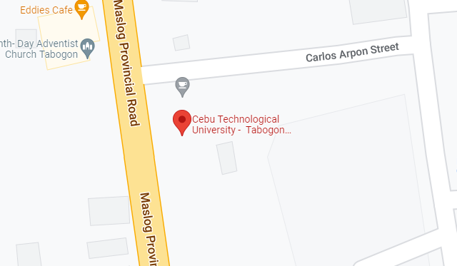

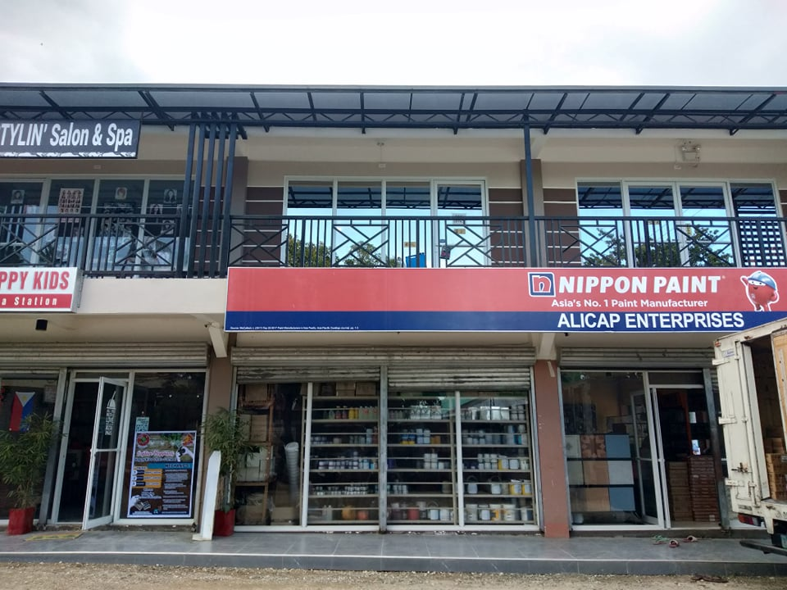

**ALICAP ENTERPRISES**

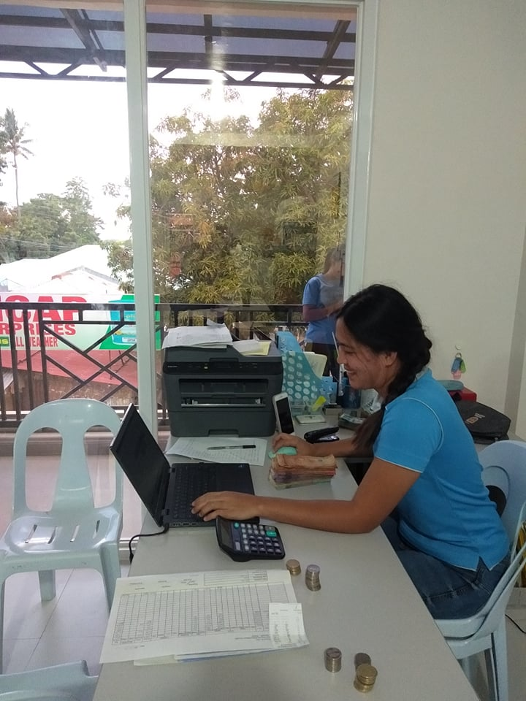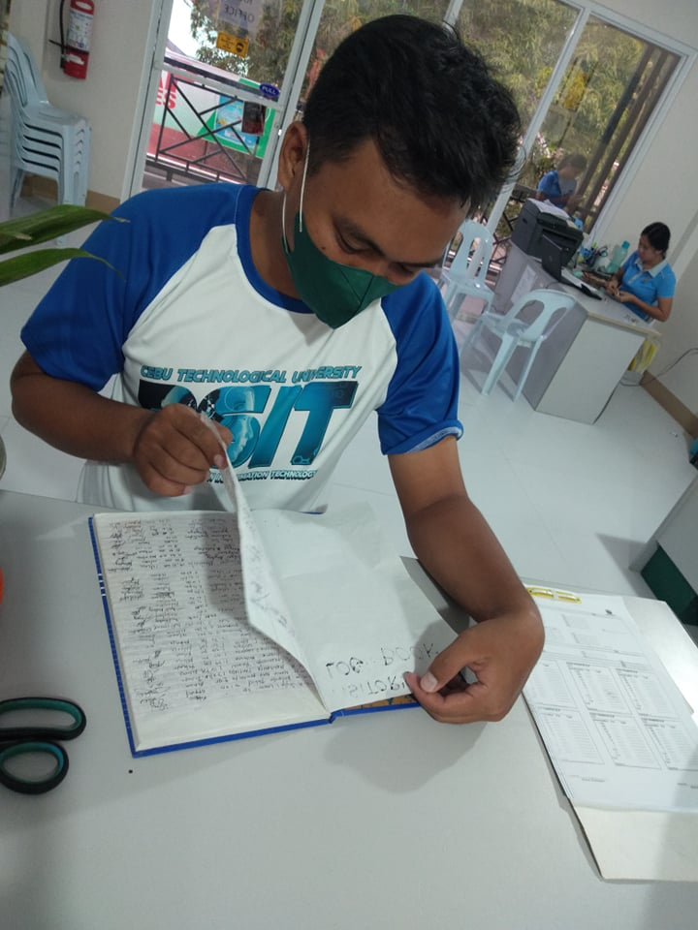

**Descriptions and functions**

The Loan Management System is responsible for securing the records for those people who applied for loan and also to maintain each transaction smooth.

**The main services are:**

1. The system will record every applied loan by the member.
2. The system will monitor the transactions of the members.
3. The admin can control all the functionalities within the system

**Location or Address**

Piyo, Tabogon, Cebu – Loan Management System

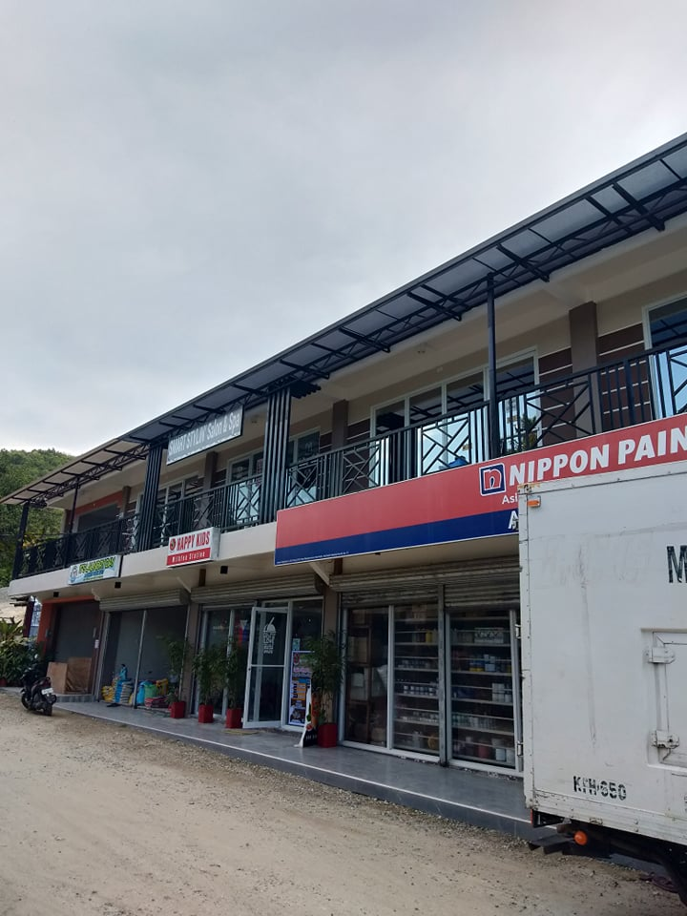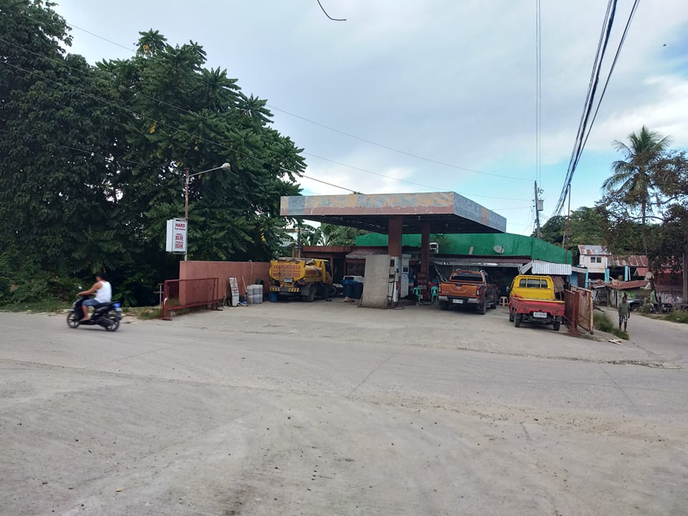

**Primary Point of Contact**

1. **Michael Urbano –** Loan Processor
2. **Marven Cortes –** Trust Staff
3. **Eman Enteko –** Trust Staff

**Current System Used (as-is-system)**

1. Manual keeping of files of the transactions happened within the building

**Problems Encountered**

1. Inaccurate records
2. Unreadable handwritten

**Proposed Improvements (to-be-system)**

Staff should computer illiterate and should now learn to adapt to the modern world where technology runs most of the transactions.

**Business Process**

The researchers proposed and suggested the **Alikap Enterprises** should now use the proposed system, Loan Management System in order for them to have an accurate record of all the transactions as well as the members management.

**Figure 9. Usefulness in Developing SCA**

1. **Clarity Requirements –** Personal information are required to be registered to the system.
2. **Familiarity with the Technology –** The user must be computer literate enough to be able to use the system.
3. **System Complexity -** The user can use the system as long as they have an account and also should have a laptop or computer, a browser and a stable internet.
4. **System Reliability –** The Loan Management system is capable of storing and securing data registered to the database.

**STAFFING PLAN**

**Project Manager**

**Technical Head**

**Functional Head**

**Analyst 2**

**Analyst 1**

**Figure 10. Staffing Plan**

|  |  |  |
| --- | --- | --- |
| **Project Manager** | Monitors the project to ensure it reaches its goals and on budget. | **Rico T.Gulben** |
| **Functional Head** | Checks that the systems suggested meet the end users’ expectations and needs. | **Fatima R. Saladaga/** **Joris A. Coyoca** |
| **Technical Head** | Track the systems compliance with end users’ specification and requirements. | **Regie S. Tagulaylay/** **Arlou R. Urot** |
| **Analyst 1** | Designs the record keeping system based on the data flow. | **Rossie P. Medillo** |
| **Analyst 2** | Designs the UI of the system. | **Jessen E. Jayme** |

**Table 2. Roles and Description of the system.**

**Working days: 70 Days**

|  |  |
| --- | --- |
| **STANDARD** | **ACTUAL** |
| **Planning Days** | **10 Days** |
| **Analysis Days** | **10 Days** |
| **Design Days** | **20 Days** |
| **Implementation Days** | **30 Days** |
| **Total Days** | **100 Days** |
|  |  |

**Table 3. Working Days (Project Time Frame)**

**Requirement Definition**

**Functional Requirements**

Functional requirements of this system capture the intended behavior of the system. This behavior may be expressed as services, tasks or functions the system is required to perform. This system registers and stores all information about loans.

**Non-functional Requirements**

In contrast with functional requirements that specify specific behavior or functions, non

functional requirements specify criteria that can be used to judge the operation of a system. The system should:

* Have sufficient resources in terms of processor speed, memory, disk space, network bandwidth.
* Have good performance in terms of response time and run time.
* Be available all the time.
* Be maintainable.
* Be able to handle several users simultaneously.
* Be reliable such that the mean time between failures is close to zero.
* Have a security mechanism to authenticate authorized users and keep out unauthorized users.
* Be robust enough to recover from failure or crash.
* Have both vertical and horizontal scalability to accommodate future expansions without losing data and applications that are already in it.

**Requirement Analysis Strategies**

**Problem Analysis**

The loan management system that is currently running at Pride Micro-finance is paper-based. This inevitably is not only time wasting but causes substantial poor records keeping. This is evidenced in loss of client information, data redundancy, long queues and as such this raises the need for a web-based loan management system that can facilitate better record keeping and security.

**Work Breakdown Structure**

|  |  |  |  |  |  |
| --- | --- | --- | --- | --- | --- |
| **Task Name** | **Start Date** | **Finish Date** | **Duration (Days)** | **Persons Involved** | **Predecessor Task** |
| **Project Planning Phase** | 04/18/22 | 04/28/22 | 10 Days | A, B, C, D, E, F, G |  |
| 1.1 Project Identification and Initiation | 04/18/22 | 04/19/22 | 1 Day | A, B, C, D, E, F, G |  |
| 1.2 System Request | 04/19/22 | 04/20/22 | 1 Day | A, B, C, D, E, F, G | 1.1 |
| 1.3 Feasibility Study | 04/20/22 | 04/21/22 | 1 Day | A, B, C, D, E, F, G | 1.2 |
| 1.3.1 Technical | 04/21/22 | 04/22/22 | 1 Day | A, B, C, D, E, F, G | 1.3 |
| 1.3.2 Economic | 04/22/22 | 04/23/22 | 1 Day | A, B, C, D, E, F, G | 1.3.1 |
| 1.3.3 Organizational | 04/23/22 | 04/24/22 | 1 Day | A, B, C, D, E, F, G | 1.3.2 |
| 1.4 Development Methodology | 04/24/22 | 04/25/22 | 1 Day | A, B, C, D, E, F, G | 1.3.3 |
| 1.5 Project Time Frame | 04/25/22 | 04/26/22 | 1 Day | A, B, C, D, E, F, G | 1.4 |
| 1.6 Staffing Plan | 04/26/22 | 04/27/22 | 1 Day | A, B, C, D, E, F, G | 1.5 |
| 1.7 Work Plan | 04/27/22 | 04/28/22 | 1 Day | A, B, C, D, E, F, G | 1.6 |
| **Analysis phase** | 04/28/22 | 05/08/22 | 10 Days | A, B, C, D, E, F, G | 1.7 |
| 2.1 Functional and Non-functional requirements | 04/28/22 | 04/29/22 | 2 Days | A, B, C, D, E, F, G | 2 |
| 2.1.1 Functional requirements | 04/29/22 | 05/01/22 | 2 Days | A, B, C, D, E, F, G | 2.1 |
| 2.1.2 Non-functional requirements | 05/01/22 | 05/03/22 | 2 Days | A, B, C, D, E, F, G | 2.1.1 |
| 2.2 Requirements Elicitation Techniques | 05/03/22 | 05/05/22 | 2 Days | A, B, C, D, E, F, G | 2.1.2 |
| 2.3 Requirement Analysis Strategies | 05/05/22 | 05/07/22 | 2 Days | A, B, C, D, E, F, G | 2.2 |
| **Design Phase** | 05/07/22 | 05/27/22 | 20 Days | A, B, C, D, E, F, G | 2.3 |
| 3.1 Design Strategy | 05/07/22 | 05/11/22 | 4 Days | A, B, C, D, E, F, G | 3 |
| 3.2 Design the architecture of the system | 05/11/22 | 05/15/22 | 4 Days | A, B, C, D, E, F, G | 3.1 |
| 3.3 Design hardware and software selections | 05/15/22 | 05/19/22 | 4 Days | A, B, C, D, E, F, G | 3.2 |
| 3.4 Design Database and file specification | 05/19/22 | 05/23/22 | 4 Days | A, B, C, D, E, F, G | 3.3 |
| 3.5 Design system navigation inputs and outpust | 05/23/22 | 05/27/22 | 4 Days | A, B, C, D, E, F, G | 3.4 |
| **Implementation phase** | 05/27/22 | 06/28/22 | 30 Days | A, B, C, D, E, F, G | 3.5 |
| 4.1 Developing the system | 05/27/22 | 05/29/22 | 2 Days | A, B, C, D, E, F, G | 4 |
| 4.1.1 Assigning programming tasks | 05/29/22 | 05/30/22 | 1 Day | A, B, C, D, E, F, G | 4.1 |
| 4.1.2 Coordinating activities | 05/30/22 | 06/01/22 | 1 Day | A, B, C, D, E, F, G | 4.1.1 |
| 4.1.3 Managing schedule | 06/01/22 | 06/03/22 | 2 Days | A, B, C, D, E, F, G | 4.1.2 |
| 4.2 Testing the system | 06/03/22 | 06/04/22 | 1 Day | A, B, C, D, E, F, G | 4.1.3 |
| 4.2.1 Test Planning | 06/04/22 | 06/06/22 | 2 Days | A, B, C, D, E, F, G | 4.2 |
| 4.2.2 Unit Test | 06/06/22 | 06/08/22 | 2 Days | A, B, C, D, E, F, G | 4.2.1 |
| 4.2.3 Integration Tests | 06/08/22 | 06/10/22 | 2 Days | A, B, C, D, E, F, G | 4.2.2 |
| 4.2.4 System Testing | 06/10/22 | 06/12/22 | 2 Days | A, B, C, D, E, F, G | 4.2.3 |
| 4.2.5 Acceptance Testing | 06/12/22 | 06/14/22 | 2 Days | A, B, C, D, E, F, G | 4.2.4 |
| 4.3 Documentation | 06/14/22 | 06/16/22 | 2 Days | A, B, C, D, E, F, G | 4.2.5 |
| 4.3.1 System Documentation | 06/16/22 | 06/18/22 | 2 Days | A, B, C, D, E, F, G | 4.3 |
| 4.3.2 User Documentation | 06/18/22 | 06/20/22 | 2 Days | A, B, C, D, E, F, G | 4.3.1 |
| 4.4 Operating Procedures | 06/20/22 | 06/22/22 | 2 Days | A, B, C, D, E, F, G | 4.3.2 |
| 4.4.1 Reference | 06/22/22 | 06/24/22 | 2 Days | A, B, C, D, E, F, G | 4.4 |
| 4.4.2 Procedures Manuals | 06/24/22 | 06/26/22 | 2 Days | A, B, C, D, E, F, G | 4.4.1 |
| 4.4.3 Tutorials | 06/26/22 | 06/28/22 | 2 Days | A, B, C, D, E, F, G | 4.4.2 |

**Chapter 5**

**USER INTERFACE DESIGN**

**HTML PROTOTYPE**

**LOG-IN PAGE**

This is the log-in page wherein the users of the system will log-in using their own credentials such as their email and password in order to access the system.

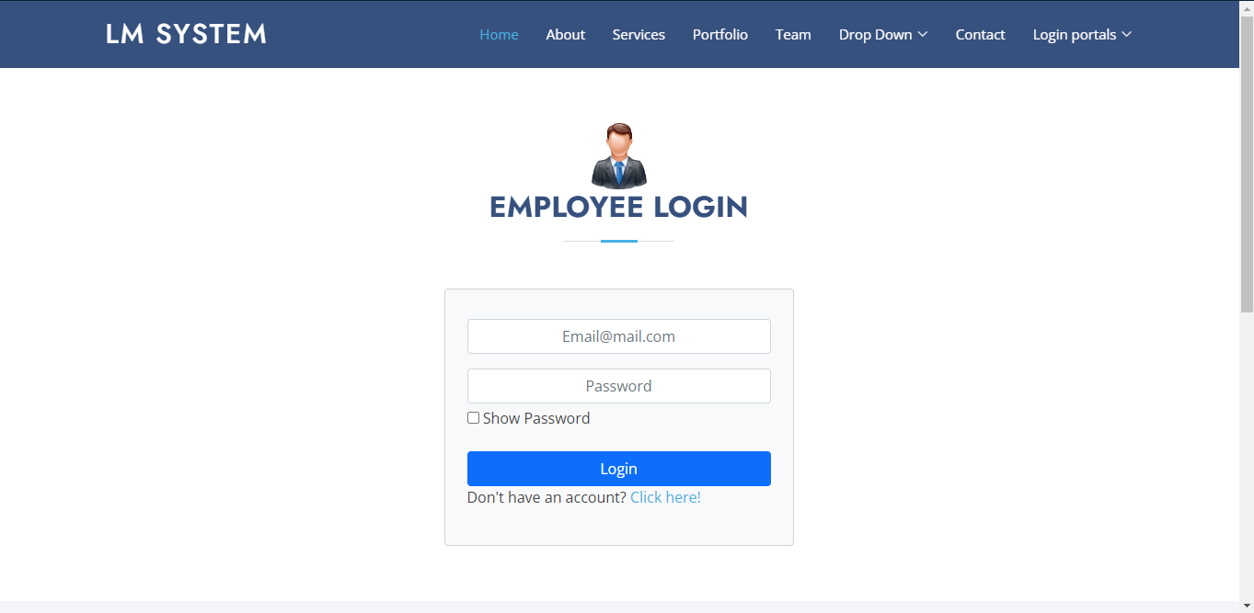

**DASHBOARD**

The dashboard display the number of records of the users, administrators, member application of the Alicab Enterprises.

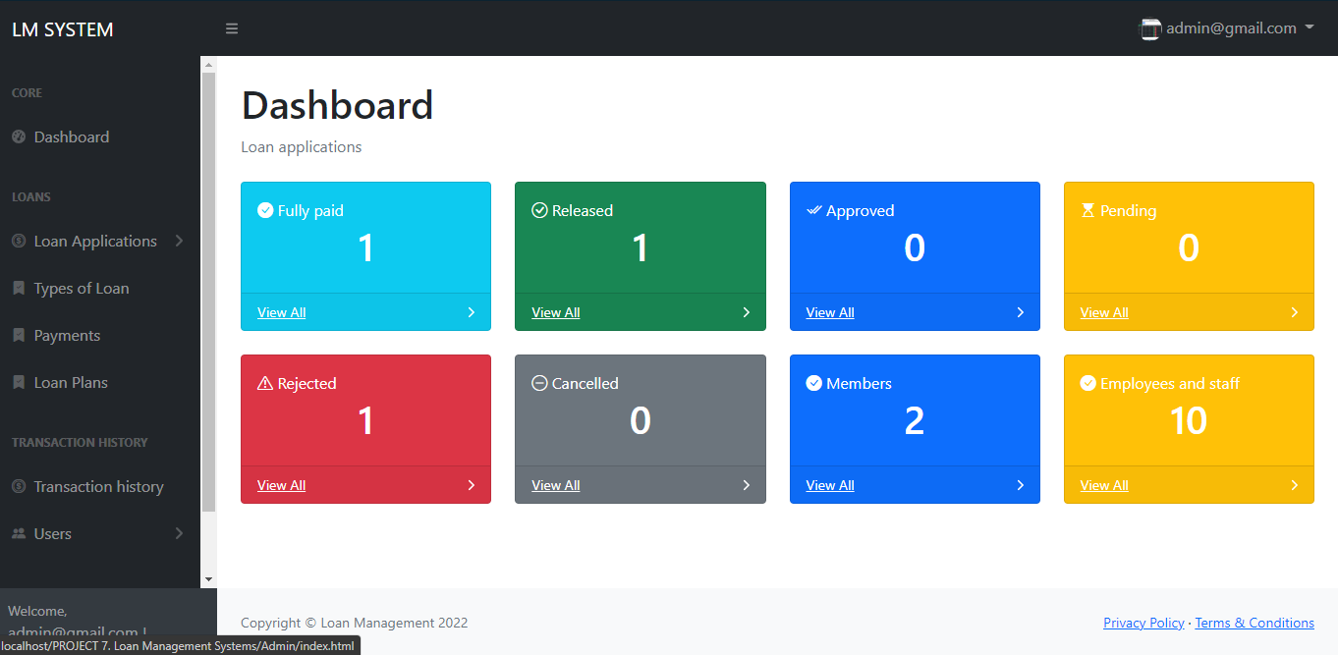

**LIST OF PENDING APPLICATION**

This is where the Administrator will see the list of member who applied for loan.

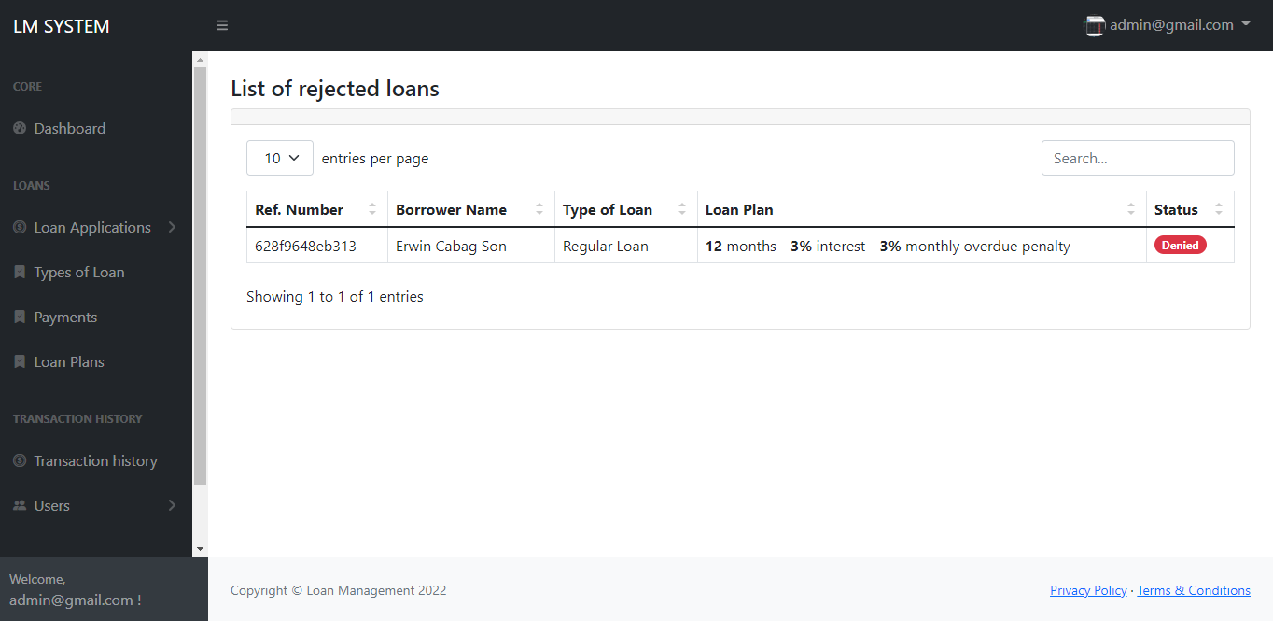

**TYPES OF LOAN**

It shows the list of types of loan in the establishment.

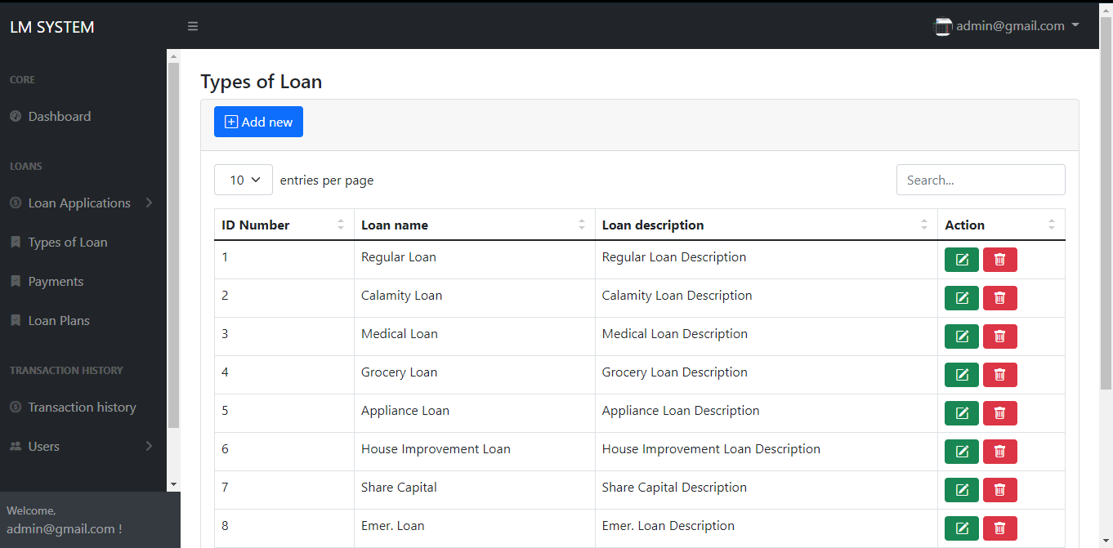

**LOAN PLANS**

Loan plans page is a page that displays the types of loan plans that consists plan(months), interest(%) and monthly overdue penalty(%).

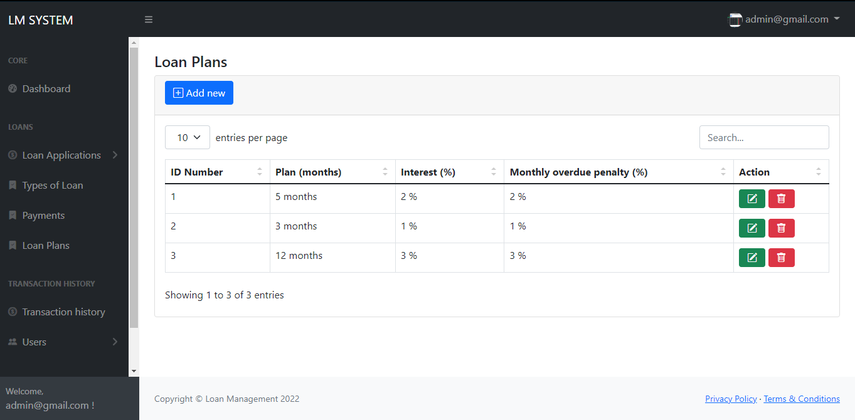

**EMPLOYEES AND STAFF**

This page displays the records of the employees and staff in Alicap Enterprises where Administrators can add, update, delete, view and search information.

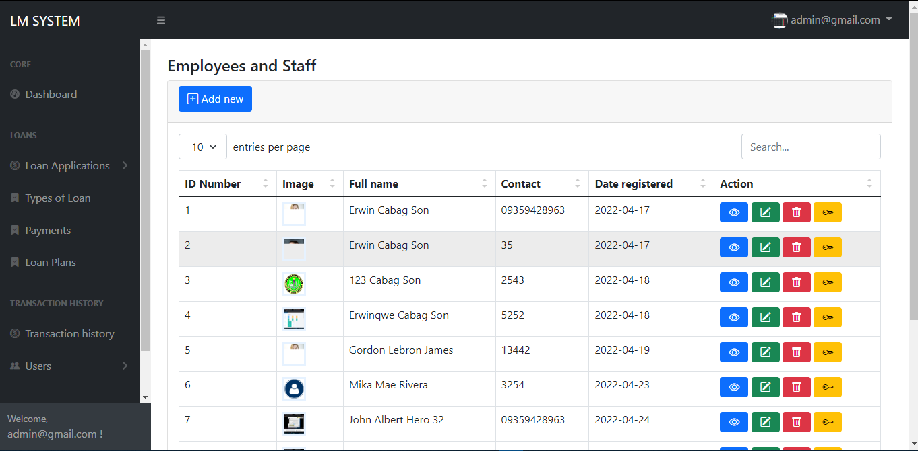

**REGISTERED USERS**

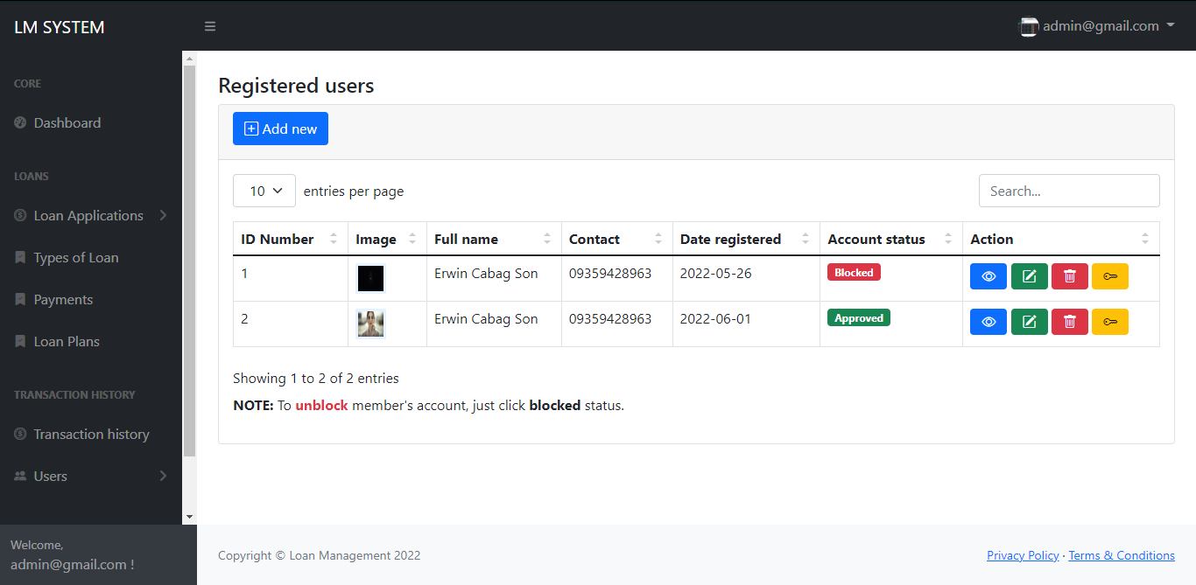Registered users’ page shows the records of the member who registered into the system.

**CHANGE PASSWORD PAGE**

Admin can change his/her password through accessing the change password page.

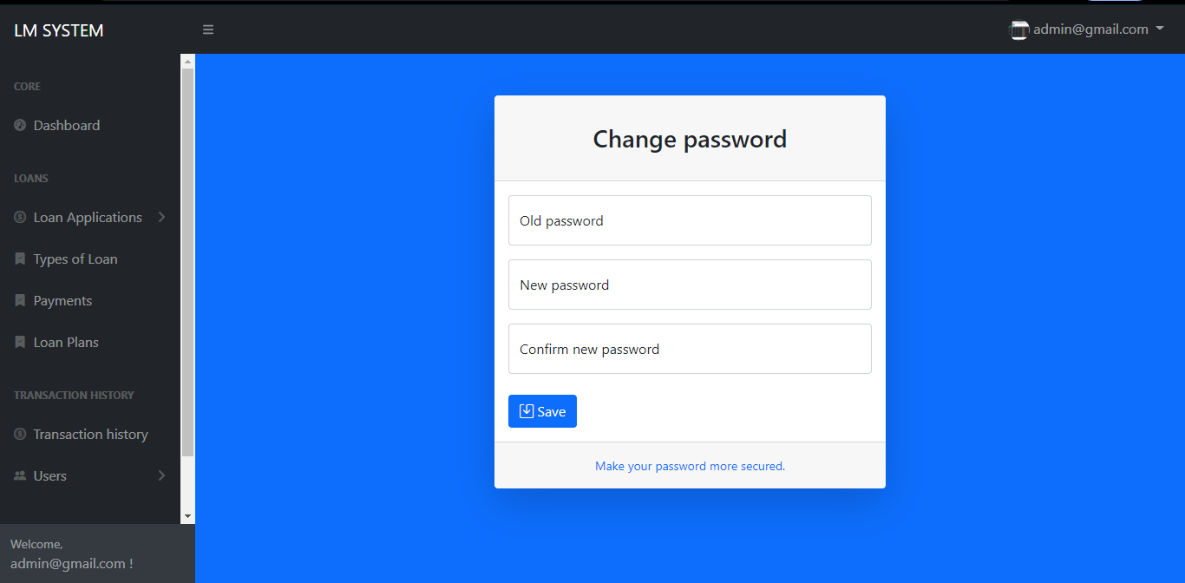

**ADMIN LOGOUT**

This system also allows users to logout their account after accessing the system.

